Assessment Tool 3
Question 2 – Healthcare Analytics Dataset

The objective of this analysis is to perform Exploratory Data Analysis (EDA) on a healthcare dataset to identify patterns and relationships among Age, Blood Sugar Level, Blood Pressure, Body Mass Index (BMI), and Disease Status. The analysis aims to understand how these health indicators are associated with the presence or absence of disease. The insights obtained from the analysis can help healthcare professionals identify risk factors, support early diagnosis, and make informed decisions for better patient care and treatment planning.
# ==========================================================
# Import Required Libraries
# ==========================================================
import pandas as pd import numpy as np import matplotlib.pyplot as plt import seaborn as sns %matplotlib inline
plt.style.use("ggplot") sns.set_theme(style="whitegrid") print("Libraries imported successfully.")
In [1]:
Libraries imported successfully.
Patient_ID
Age
Sugar_Level
BP
BMI
Disease_Status

# ==========================================================
# Create Healthcare Dataset
# ==========================================================
healthcare = {
"Patient_ID":["P01","P02","P03","P04","P05","P06","P07","P08","P09","P10",
"P11","P12","P13","P14","P15","P16","P17","P18","P19","P20"],
"Age":[45,32,55,28,60,40,52,35,48,30,62,38,50,27,58,42,46,34,53,29],
In [2]:
"Sugar_Level":[145,98,180,90,200,120,165,105,155,95,210,115,170,88,190,130,150,
"BP":[130,118,145,110,150,125,140,120,135,115,155,122,142,108,148,128,132,116,1
"BMI":[28,23,31,22,34,26,30,24,29,23,35,25,30,21,33,27,28,24,31,22],
"Disease_Status":["Yes","No","Yes","No","Yes","No","Yes","No","Yes","No", "Yes","No","Yes","No","Yes","No","Yes","No","Yes","No"]
} df2 = pd.DataFrame(healthcare) df2.head()

Feature | Description | Data Type
Patient_ID | Unique identification number assigned to each patient | Integer
Age | Age of the patient (in years) | Integer
Sugar_Level | Blood sugar level of the patient | Numeric (Float/Integer)
BP | Blood pressure of the patient | Numeric (Float/Integer)
BMI | Body Mass Index of the patient | Numeric (Float)
Disease_Status | Indicates whether the patient has the disease (Yes/No or Positive/Negative) | Categorical

P01 | 45 | 145 | 130 | 28 | Yes
P02 | 32 | 98 | 118 | 23 | No
P03 | 55 | 180 | 145 | 31 | Yes
P04 | 28 | 90 | 110 | 22 | No
P05 | 60 | 200 | 150 | 34 | Yes
This dataset contains patient health information collected to analyze the relationship between Age, Blood Sugar Level, Blood Pressure (BP), Body Mass Index (BMI), and Disease Status. The primary purpose of the dataset is to identify patterns and trends that may indicate the presence or absence of disease.
By performing Exploratory Data Analysis (EDA), healthcare professionals can better understand how these health indicators are related to disease outcomes. The insights obtained from the analysis can support early disease detection, risk assessment, preventive healthcare strategies, and informed medical decision-making, ultimately contributing to improved patient care and health outcomes.

# ==========================================================
# Dataset Information
# ==========================================================
print("Shape of Dataset:") print(df2.shape)
print("\nDataset Information:") df2.info()
print("\nData Types:") print(df2.dtypes)
In [3]:
Shape of Dataset:
(20, 6)
Dataset Information:
RangeIndex: 20 entries, 0 to 19 Data columns (total 6 columns):
# Column Non-Null Count Dtype --- ------ -------------- ---- 0 Patient_ID 20 non-null str
- Age 20 non-null int64
- Sugar_Level 20 non-null int64
- BP 20 non-null int64
- BMI 20 non-null int64 5 Disease_Status 20 non-null str dtypes: int64(4), str(2) memory usage: 1.1 KB
Data Types:
Patient_ID str
Age int64
Sugar_Level int64
BP int64
BMI int64 Disease_Status str dtype: object
# ==========================================================
# Data Cleaning
# ==========================================================
print("Missing Values") print(df2.isnull().sum())
print("\nDuplicate Records") print(df2.duplicated().sum())
In [4]:
Missing Values
Patient_ID 0
Age 0
Sugar_Level 0
BP 0
BMI 0 Disease_Status 0 dtype: int64
Duplicate Records
# ==========================================================
# Check for Incorrect Entries
# ==========================================================
print("Unique Disease Status Values:") print(df2["Disease_Status"].unique())
0 In [5]:
Unique Disease Status Values:
<StringArray>
['Yes', 'No']
# ==========================================================
# Descriptive Statistics
# ========================================================== print(df2.describe())
Length: 2, dtype: str In [6]:
Age Sugar_Level BP BMI count 20.000000 20.00000 20.000000 20.000000 mean 43.200000 138.65000 129.750000 27.300000 std 11.316499 40.33449 14.523574 4.256265 min 27.000000 88.00000 108.000000 21.000000 25% 33.500000 99.50000 117.500000 23.750000
50% 43.500000 137.50000 129.000000 27.500000 75% 52.250000 171.25000 142.500000 30.250000 max 62.000000 210.00000 155.000000 35.000000
The dataset contains 20 patient records and 6 features.
No missing values or duplicate records were found.
Disease_Status contains only valid categories (Yes and No).
The dataset is clean and ready for further analysis.

# ==========================================================
# Numerical Analysis
# ==========================================================
print("Average Age:", df2["Age"].mean()) print("Average Sugar Level:", df2["Sugar_Level"].mean()) print("Average Blood Pressure:", df2["BP"].mean()) print("Average BMI:", df2["BMI"].mean())
print("\nDisease Status Count:") print(df2["Disease_Status"].value_counts())
In [8]:
Average Age: 43.2
Average Sugar Level: 138.65
Average Blood Pressure: 129.75
Average BMI: 27.3
Disease Status Count:
Disease_Status
Yes 10
No 10
Name: count, dtype: int64

# ==========================================================
# Box Plot for Outlier Detection
# ==========================================================
plt.figure(figsize=(6,4)) plt.boxplot(df2["Sugar_Level"]) plt.title("Box Plot of Sugar Level") plt.ylabel("Sugar Level") plt.show()
In [10]:
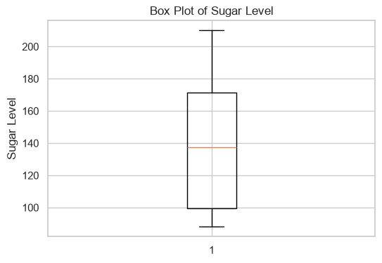
Data Visualization
# ==========================================================
# Histogram
# ==========================================================
plt.figure(figsize=(6,4)) plt.hist(df2["Age"], bins=6, edgecolor="black") plt.title("Age Distribution") plt.xlabel("Age") plt.ylabel("Number of Patients") plt.show()
In [11]:
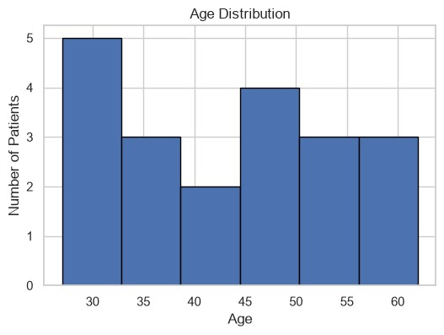
# ==========================================================
# Bar Chart
# ==========================================================
plt.figure(figsize=(6,4))
df2["Disease_Status"].value_counts().plot(kind="bar", color=["green","red"])
plt.title("Disease Status Distribution") plt.xlabel("Disease Status") plt.ylabel("Number of Patients") plt.show()
In [12]:
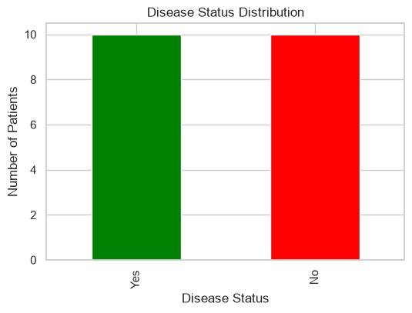
# ==========================================================
# Scatter Plot
# ========================================================== plt.figure(figsize=(6,4)) plt.scatter(df2["Sugar_Level"], df2["BMI"])
plt.title("Sugar Level vs BMI") plt.xlabel("Sugar Level") plt.ylabel("BMI") plt.show()
In [13]:
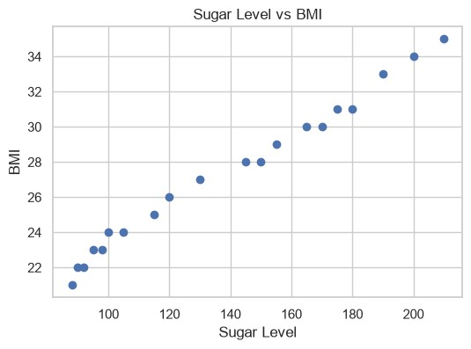
# ==========================================================
# Pie Chart
# ========================================================== plt.figure(figsize=(5,5))
df2["Disease_Status"].value_counts().plot( kind="pie", autopct="%1.1f%%"
)
plt.title("Disease Status Percentage") plt.ylabel("") plt.show()
In [14]:
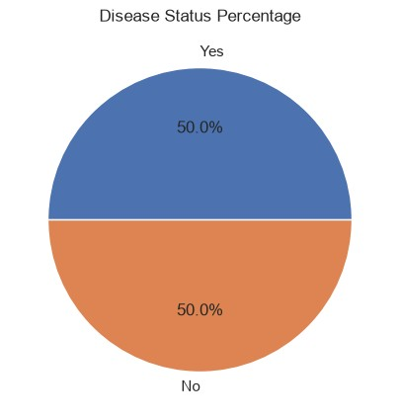
# ==========================================================
# Heatmap
# ========================================================== plt.figure(figsize=(6,4))
sns.heatmap( df2.select_dtypes(include=np.number).corr(), annot=True, cmap="coolwarm"
)
plt.title("Correlation Heatmap") plt.show()
In [15]:
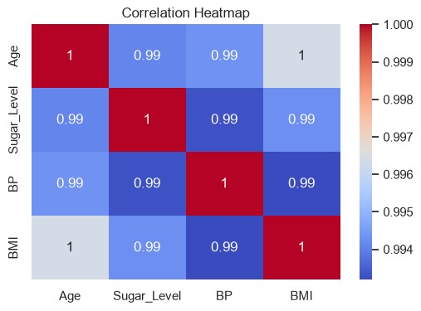
- Patients with higher blood sugar levels generally have higher BMI values.
- Older patients are more likely to have higher blood pressure.
- The dataset contains an equal number of patients with and without disease.
- No missing values or duplicate records were found.
- The heatmap indicates positive relationships among age, sugar level, blood pressure, and BMI.
The Exploratory Data Analysis (EDA) indicates that higher blood sugar levels, blood pressure, and Body Mass Index (BMI) are commonly associated with patients diagnosed with the disease. The dataset was cleaned and preprocessed successfully, making it suitable for accurate analysis. The results highlight important health indicators that can help identify individuals who may be at a higher risk of developing the disease. These insights can assist healthcare professionals and hospitals in early diagnosis, risk assessment, preventive healthcare planning, and informed medical decision-making, ultimately improving patient care and treatment outcomes.
In [ ]:

